1 a) Distinguish between a scalar and a vector quantity.
b) Which of the following physical quantities are vectors? Justify your choice.

displacement, distance, heat, kinetic energy, power, force, weight, pressure, resistance, electromotive force (e.m.f.).

2 a) 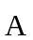 and  are two vectors acting at right angles. Draw labelled diagrams to show the vector addition 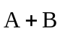 and the vector subtraction 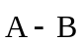.
b) State the magnitudes of the resultants and their directions with respect to .

3. The x and y components of velocity of a particle are 25 m/s and 60 m/s respectively. Find the magnitude and direction of the velocity vector.

4. Find the resultant of two forces of 10 N and 20 N acting at a point such that the angle between the forces is
a) 60º
b) 30º

5. A car changes its velocity from 30 m s⁻¹ due East to 25 m s⁻¹ due South. Draw a vector diagram to show the initial, final and change of velocity of the car.

6. Use vector components to find the magnitude and direction of the vector needed to balance two vectors shown in figure. Let the 625 N vector be along the –y axis and let the +x axis be perpendicular to it toward the right.

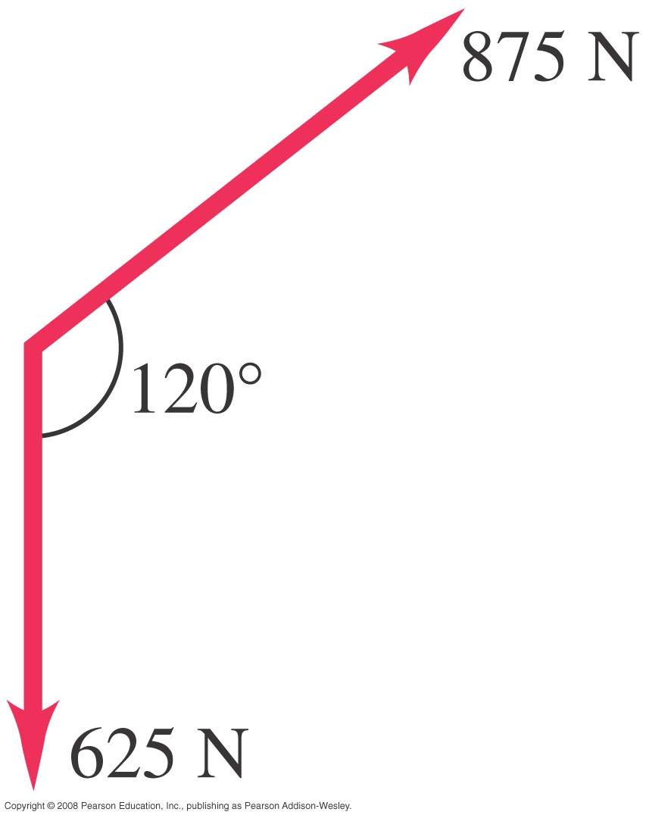

7. In each case, find the x and y components of vector :
a) 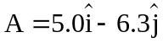
b) 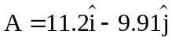
c) 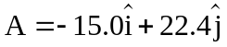
d) 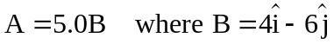

8. Find the angle between each of the following pairs of vectors :
a) 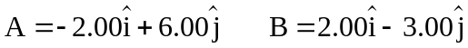
b)
c)

9. The two vectors andhave magnitude A=3.00 and B=3.00. Their vector product is 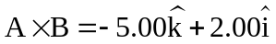. What is the angle between and?

Answers

3. 65 m/s, tan⁻¹ (60/25)=67.4º with positive x-axis
4. 26.4, 40.9º, 29.1 N, 20.1º
6. 781 N, 166.1º from +x axis

7. a) 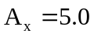, 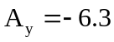, b) 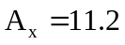, 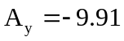, c) 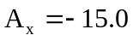, 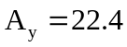

d) 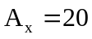, 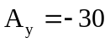
8. 165º, 28º, 90º
9. 36.8º

